ICET 2019 |  |  |  | Full Paper
Monitoring of Traffic using Unmanned Aerial Vehicle in Malaysia Landscape Perspective  Azizul Abdullahª, Elmi Abu Bakar^{b*}, Muhammad Zaim Mohamed Pauziª  ªSchool of Mechanical Engineering, Engineering Campus, USM, 14300, Nibong Tebal, Penang, Malaysia  ^{b}School of Aerospace Engineering, Engineering Campus, USM, 14300, Nibong Tebal, Penang, Malaysia |  |  | Article history  Received  1 February 2018  Received in revised form  24 March 2015  Accepted  1 August 2018  *Corresponding author  meelmi@tatiuc.edu.my
Graphical abstract  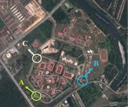 |  | Abstract  Collecting information on traffic flows are important for provide high quality road system. At present, fixed camera is widely used for the monitoring system which covers limited area. Therefore, the unmanned aerial vehicle (UAV) such as quadrotor is developed for monitoring traffic flow since the UAV is responsive mobile sensing system. This development of UAV platform is a starting point for developed a highway traffic and management system which is in future can be enhance by connected the system with graphical user interface (GUI) on ground control station that can defined types of vehicles and analyze level of congestion. At present, the system that developed only transmits a real time video to ground control station without any interpretation by software that detects types of vehicles and analyzes traffic condition. Through the surveillance and monitoring of traffic flows that done at Engineering Campus, Universiti Sains Malaysia.  Keywords: Highway traffic flow, unmanned aerial vehicle, quadrotor, real time video
 |  | © 2019 ICET 2019. All rights reserved

1.0 INTRODUCTION

Traffic management and accident management is very important for human in congestion city in order to provide comfortable lifestyle and safety. By having this system, people will haved real-time information on traffic conditition around the city, which can avoid from stuck on traffic jam. At present, ground-based solution are widely used to monitor traffic condition in a small and fixed coverage area which is stationary and short view sight.
For example, Versavel (1999) used multiple camera in order to developed a system for traffic monitoring, incident detection, verification, driver information and incident clearing [1]; as noted in Ozkurt and Camci (2009), Istanbul Traffic Management Company (ISBAK) have been used more than 500 cameras for traffic monitoring which this amount is applied in the manual analysis of these camera system is now unapplicable [2]; Koutsia et al., (2008) used multiple camera for capturing images and detect foreground objects within their field of view in order to developed traffic monitoring and surveillance system [3]; and Yoneyama et al., (2005) used fixed camera for detecting vehicles on highway [4].
In order to overcome the limitation of fixed camera for traffic monitoring, the reseachers had explored a new and improved traffic monitoring technology since 1990s which is known as an airborne traffic surveillance system (ATSS) which used Unmanned Aerial Vehicle (UAVs) as a platform [5, 6]. As mention by Coifman et al., (2006), the primary reason of using UAV as platform for ATSS is UAV can be covered large area and focus resources. Beside that, it also have a capability to fly at higher speed than ground vehicles and freely to fly along the road network except in tunnel [7].
In the most of developing ATSSs, an offline method are widely used which is the aerial video of traffic flow were recorded during flight of UAV and then processed on ground in order to analyse behaviour of traffic [8, 9]. This processing mode is unable to achieve real time traffic monitoring and management. However, in growth of advance technology such wireless network, an online mode has been proposed. One of the reseach that used wireless network which the aerial video is trasmitting to ground by using a 2.4-Ghz microwave IP network is implement by Srinivasan et al., 2004 [10]. This system needed specific construction such as microwave tower that involve high cost and the coverage area is limited since it only work based on radius of signal received and trasmited by microwave tower.
Here, the similar method that been used by Srinivasan et al., which is used wireless network for trasmit the aerial video capture by UAV to ground control station. However, in this research, it not used microwave tower as a receiver to receive a data since it used 5.8G 2000mW wireless audio video receiver that connected to ground control station to display a data colllection.. This method is more convenient since it not depend on the microwave tower. Since the highway traffic flow is very dynamic and uncertain environment that requires instantaneous and accurate information, a selection of types of UAV as a platform for capturing aerial video/image is very important.
Among the UAVs developed in recent year that involved fixed wing and rotorcraft types, a serious focus has been placed on developing a quadrotor UAV (rotorcraft type) due to it capabilities to hover in place, to take-off and landing vertically, very agile and responsive mobile sensing system [11, 12, 13]. Due to this ability, the quadrotor is considered as one of the most suitable choices to do traffic monitoring due to it capability and cost effective since the UAV is already available commercially. Eventhough quadrotor is already on market, there are no quadrotor that build and dedicated for traffic monitoring. Here, the quadrotor is developed with the system that can be used for traffic monitoring.

2.0 METHODOLOGY

In order to do traffic monitoring, a quadrotor which known as ISI Sky I (Figure 1) is used based on specification as stated in Table 1 and Table 2 showed the quadrotor componentsrespectively. On ground control station, it has on-screen display (OSD) as depicted in Figure 2 whilst Table 3 shown the parameters display by OSD. These systems are important to display real time video on ground so that the user can make decision immediately in case an emergency or an accident occurs on the road. Therefore, the authorities can make action faster in order to prevent more danger to road users.

Table 1 Specification of ISI Sky I

No. | Parameters | Capability Values
1 | Flight time (minute) | 15
2 | Take-off weight (kg) | <2.0
3 | Altitude (m) | 100 – 300
4 | Payload (kg) | 0.250
5 | Radio System Frequency (GHz) | 2.4

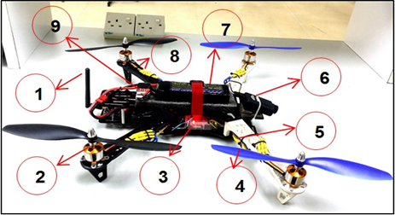

Figure 1 ISI Sky I configuration

Table 2 Components of ISI Sky I

No. | Component
1 | 5.8G 2000mW wireless audio video transmitter
2 | Brushless motor
3 | Flight controller
4 | Propeller
5 | Electronic speed controller (ESC)
6 | Camera
7 | Lithium polymer battery
8 | Quadrotor arm
9 | Battery checker
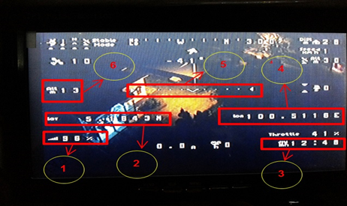

Figure 2 OSD display on ground control station

Table 3 Parameters display by OSD

No. | Component
1 | Percentage of signal
2 | Latitude position
3 | Flight time
4 | Longitude position
5 | Indicator for levelling
6 | Altitude

Traffic monitoring system mainly consists of FPV system which is attached to quadrotor and on ground system. The component that attached to both systems is shown in Figure 3.

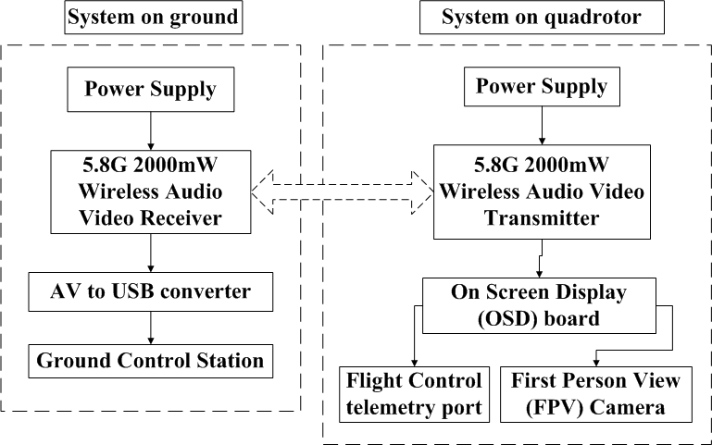

Figure 3 System prototype architecture of FPV

Hence, this system will be used for traffic and emergency management. There are several environments that will study for traffic flow and emergency condition as shown in Figure 4.
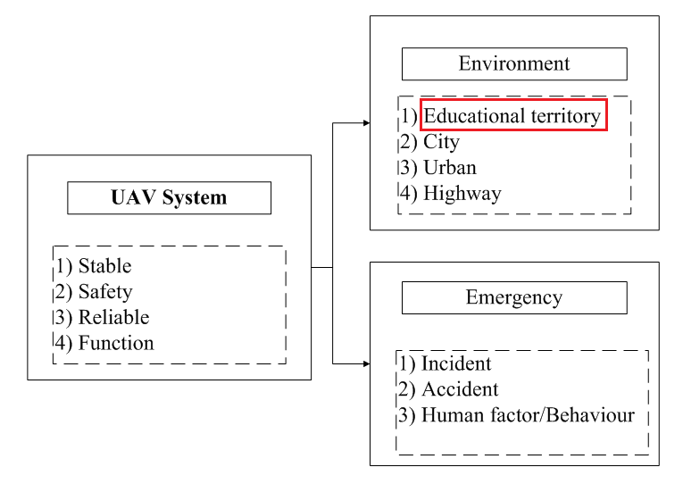

Figure 4 Environments condition for traffic monitoring

Even though there are several environments to study, here only traffic flow in educational territory is discussed as mark in Figure 4. Therefore, traffic flow inside Engineering Campus, Universiti Sains Malaysia is selected as a case study as shown in Figure 5. The area of monitoring is not so large since it just for testing the quadrotor platform whether the quadrotor is stable or not while for camera, it can provide high quality of image/video or not. There are three areas of traffic flow that were surveyed as marks on Figure 8 since the engineering campus have three entrances. The area is marked as A is the main entrance whilst the area is marked as B and C are alternative entrance respectively.

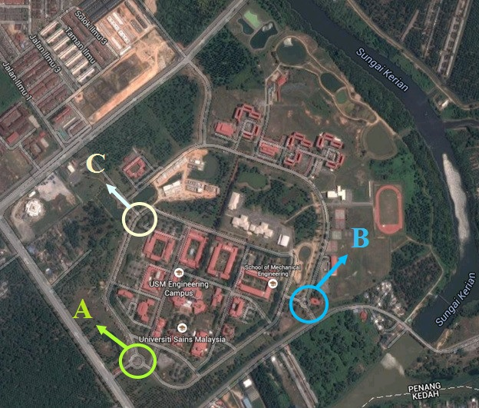

Figure 5 Area of monitoring and surveillance

This testing is a starting point for developed a traffic and management system which is in future can be enhance by connected the system with graphical user interface (GUI) on ground control station that can defined types of vehicles and analyze level of congestion. At present, the system that developed only transmits a real time video on ground without any interpretation by software that detects vehicles and analyzes traffic condition. During flight, in order to provide high quality of images, a camera is attached to gimbal which the gimbal can minimize the vibration caused by motors of quadrotor and environment disturbance such as wind.

3.0 RESULTS AND DISCUSSION

The aerial videos are collect at time duration from 8.00 am to 8.10 am on every Monday for each entrance which the selection of time is due to peak hour of staff and student to enter the campus. The results of monitoring are shown in Table 4 and Table 5 respectively.

Table 4 Total of vehicles for each entrance

Types of Vehicle | Entrance
Types of Vehicle | A | B | C
Bicycle | 5 | 0 | 11
Motorcycle | 23 | 8 | 16
Car | 38 | 17 | 21
Van | 1 | 0 | 0
Lorry | 1 | 1 | 0

Table 5 Condition of traffic flow and traffic violation

Flow of Vehicle | Entrance
Flow of Vehicle | A | B | C
Traffic jam | Sometime | Excellent | Excellent
Violation flow | None | Sometime | Sometime

As depicted in Table 4, the results show that more vehicles are using the route at entrance A compare with entrance B and entrance C. Since the entrance A is main entrance, this results is expected. For entrance B, there a less vehicles that used this route since the road that linking to the entrance is not main road compare to entrance A and entrance C. In entrance C, it indicate that there are a lot of bicycle that used this entrance since near the entrance, it has an area for student settlement which the students used a bicycle as main transport for commute to campus. As shown in Table 5, entrance A sometime face a traffic jam condition due to some events organized by university. Therefore, more vehicles focus on entrances A compare entrance B and entrance C since entrance B and entrance C will closed during events.
Figure 6, Figure 7 and Figure 8 are shown a traffic condition respectively which is at entrance A is recorded vehicles coming in large numbers in certain period compare at entrance B and entrance C. Meanwhile, at entrance A, during the aerial video is recorded and transfer real time to ground control station, there are no traffic violation is detected compare to at entrance B and entrance C whilst entrance B and entrance C has a traffic violation as depicted in Figure 7b and Figure 8b respectively. The drivers in Figure 7b and Figure 8b should follow the route as shown in the arrow in order to follow the rule. There is no traffic violation at entrance A since the post guard is near to the roundabout so that the driver did not dare to break the rules. Besides that, the number of guards at entrance A is more compare to entrance B and entrance C while entrance A has four to five guards at one time compare only one guard at entrance B and entrance C.

4.0 CONCLUSION

In this study, a quadrotor UAV integrated with camera have been developed and tested in order to provide real time aerial video for traffic and emergency management. Through this study, the quadrotor can provide suitable information for ground staff to determine level of congestion and at the same time can monitor traffic violation by driver. This situation can be used when incident or accident happened which is can prevent road users used emergency land since this platform can send real time condition so that the authorities can take immediate action.

Acknowledgement

This research is fully supported by ERGS grant, 203/PAERO/6730118. The authors fully acknowledged Ministry of Higher Education (MOHE) and Universiti Sains Malaysia for the approved fund which makes this important research viable and effective.

References

- Versavel, J. 1999. Road Safety Through Video Detection. Intelligent Transportation System, 1999, Proceedings 1999 IEEE/IEEJ/JSAI International Conference. 753-757.
- Ozkurt, C., and Camci, F. 2009. Automatic Traffic Density Estimation and Vehicle Classification for Traffic Surveillance System Using Neural Networks. Mathematical and Computer Applications. 14(3): 187-196.
- Koutsia, A., Semertzidis, T., Dimitropoulos, K., Grammalidis, N., & Georgouleas, K. 2008, June. Intelligent Traffic Monitoring and Surveillance with Multiple Cameras. In Content-Based Multimedia Indexing, 2008. CBMI 2008. International Workshop on IEEE. 125-132.
- Yoneyama, A., Yeh, C. H. and JayKuo, C. C. 2005: Robust Vehicle and Traffic Information Extraction for Highway Surveillance. Eurasip Journal on Applied Signal Processing 2005. 2305-21.
- Parameswaran, V., Burlina, P. and Chellappa, R. 1997. Performance Analysis and Learning Approaches for Vehicle Detection and Counting in Aerial Images. Proceedings of IEEE International Conference on Acoustics, Speech, and Signal Processing. 4: 2753-2756.
- Redding, N. J., Booth, D. M. and Jones, R. 2005. Urban video Surveillance from Airborne and Ground-based Platforms. Proceedings of the IEEE International Symposium on Imaging for Crime Detection and Prevention. 79-84.
- Coifman, B., McCord, M., Mishalani, R. G., Iswalt, M., & Ji, Y. 2006, March. Roadway Traffic Monitoring from an Unmanned Aerial Vehicle. In IEE Proceedings-Intelligent Transport Systems. 153(1): 11-20.
- Angel, A., Hickman, M., Mirchandani, P. and Chandnani, D. 2002. Application of Aerial Video for Traffic Flow Monitoring and Management. Proceedings of the 7th International Conference on Applications of Advanced Technology in Transportation. 346-53.
- Medioni, G., Cohen, I., BreAˆ mond, F., Hongeng, S. and Nevatia, R. 2001. Event Detection and Analysis from Video Streams. IEEE Transactions on Pattern Analysis and Machine Intelligence. 23: 873-89.
- Srinivasan, S., Latchman, H., Shea, J., Wong, T., & McNair, J. 2004, October. Airborne Traffic Surveillance Systems: Video Surveillance of Highway Traffic. In Proceedings of the ACM 2nd International Workshop on Video Surveillance & Sensor Networks. 131-135.
- Roldán, J. J., Joossen, G., Sanz, D., del Cerro, J., and Barrientos, A. 2015. Mini-UAV Based Sensory System for Measuring Environmental Variables in Greenhouses. Sensors. 15(2): 3334-3350.
- Mohamed, N., Al-Jaroodi, J., Jawhar, I., & Lazarova-Molnar, S. 2013, May. Middleware Requirements for Collaborative Unmanned Aerial Vehicles. In Unmanned Aircraft Systems (ICUAS), 2013 International Conference on IEEE. 1051-1060.
- Bedford, M. A. 2015. Unmanned Aircraft System (UAS) Service Demand 2015-2035.

